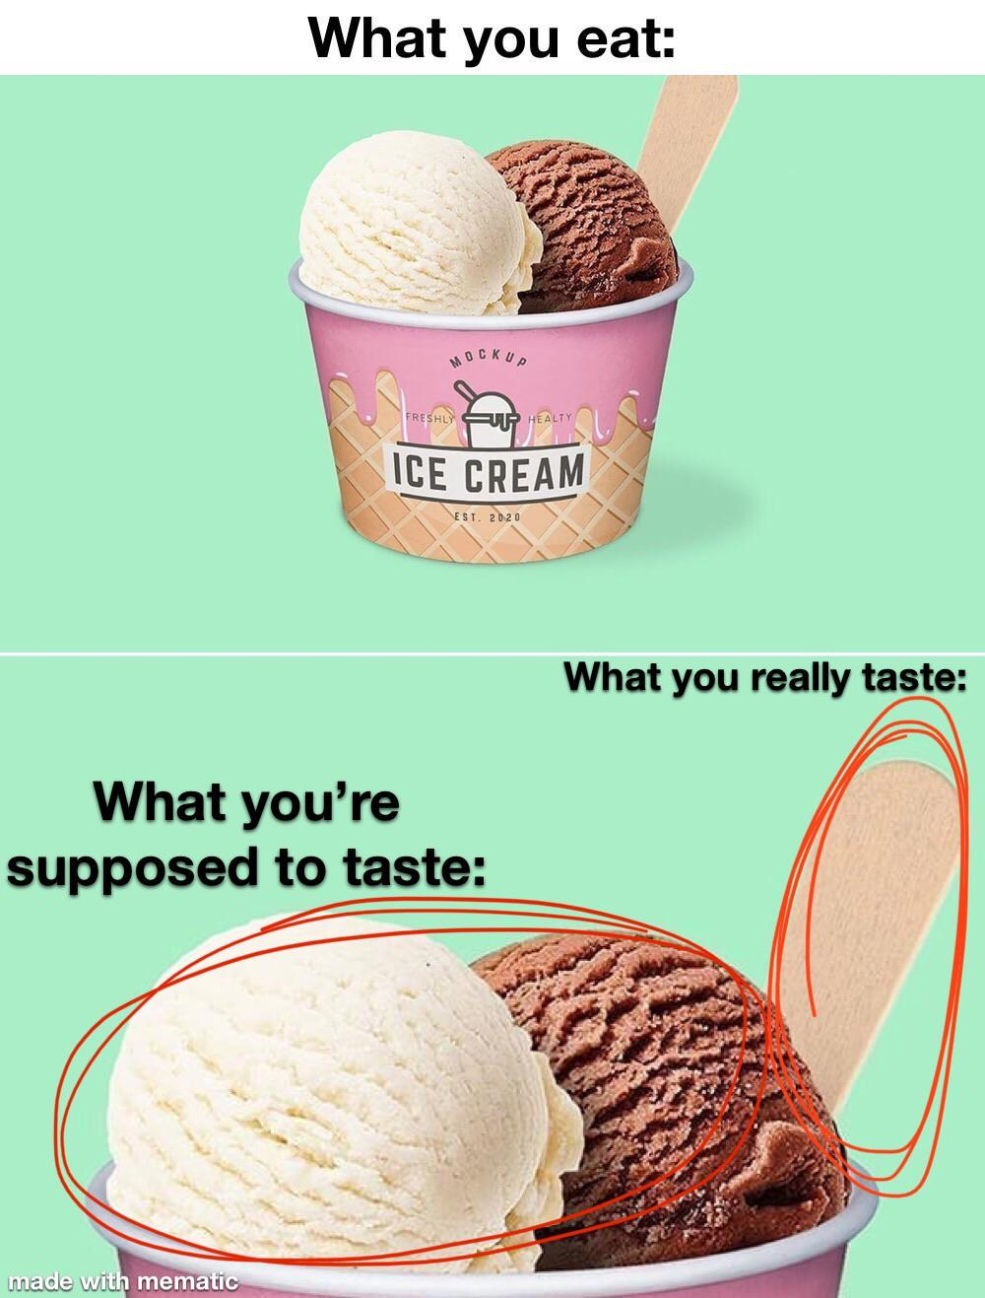

1. Description, Utterly delicious ice cream made from fresh milk available in a wide range of flavours and packs. ; Cup, 125 ml, 100 ml, 80 ml, 90 ml & 40 ml ; Fat ...
2. 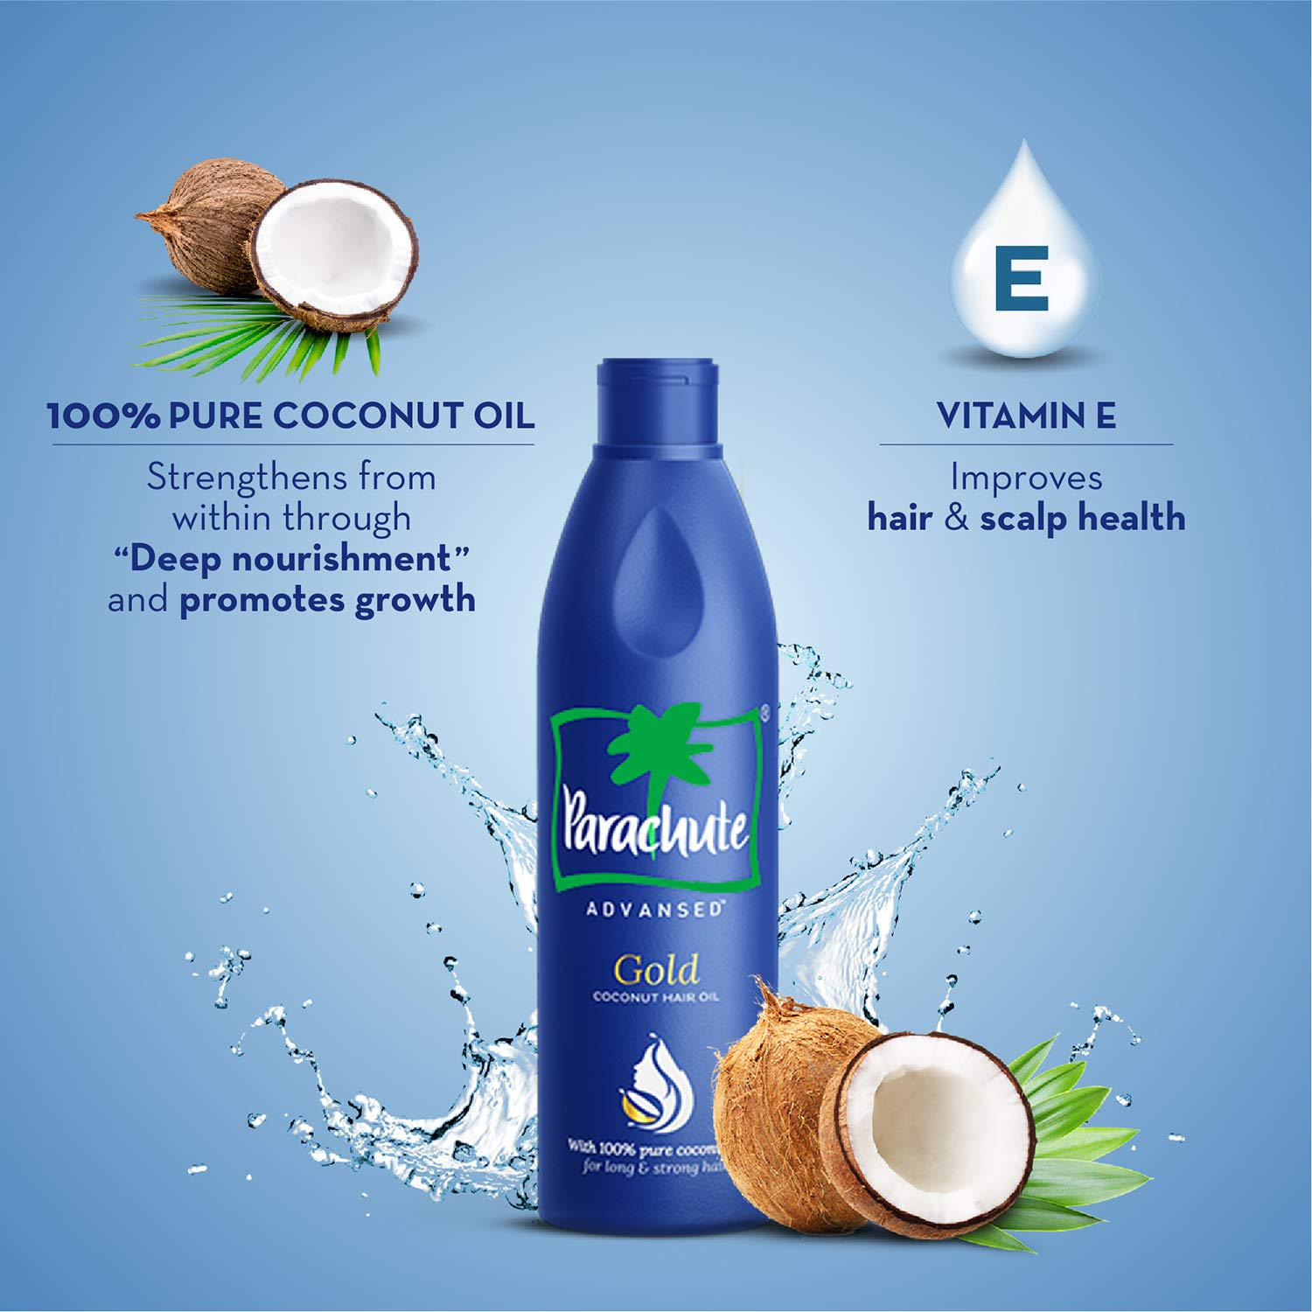 **parachute is a brand name for a range of coconut-based oil manufactured by marico.**

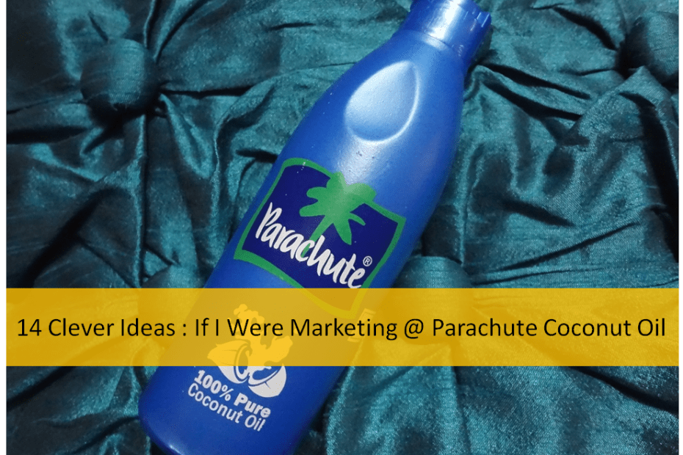

Parachute Coconut Oil can be used for cooking as well as applied to the skin to keep it moisturized and to the hair to let your hair become strong, shiny and immune to breakage. You will not need a doctor's prescription to buy this coconut oil

3.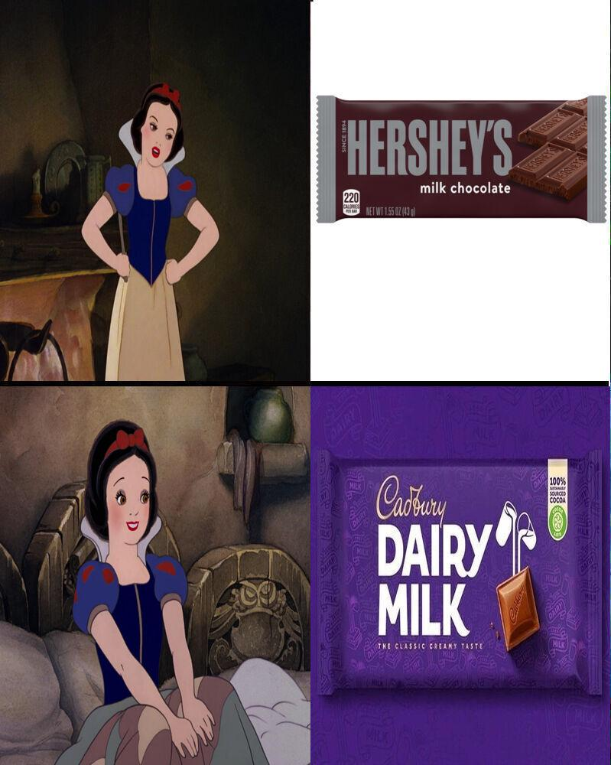Cadbury Dairy Milk is a British brand of milk chocolate manufactured by Cadbury. It was introduced in the United Kingdom in June 1905 and now consists of a number of products. Every product in the Dairy Milk line is made with exclusively milk chocolate

4.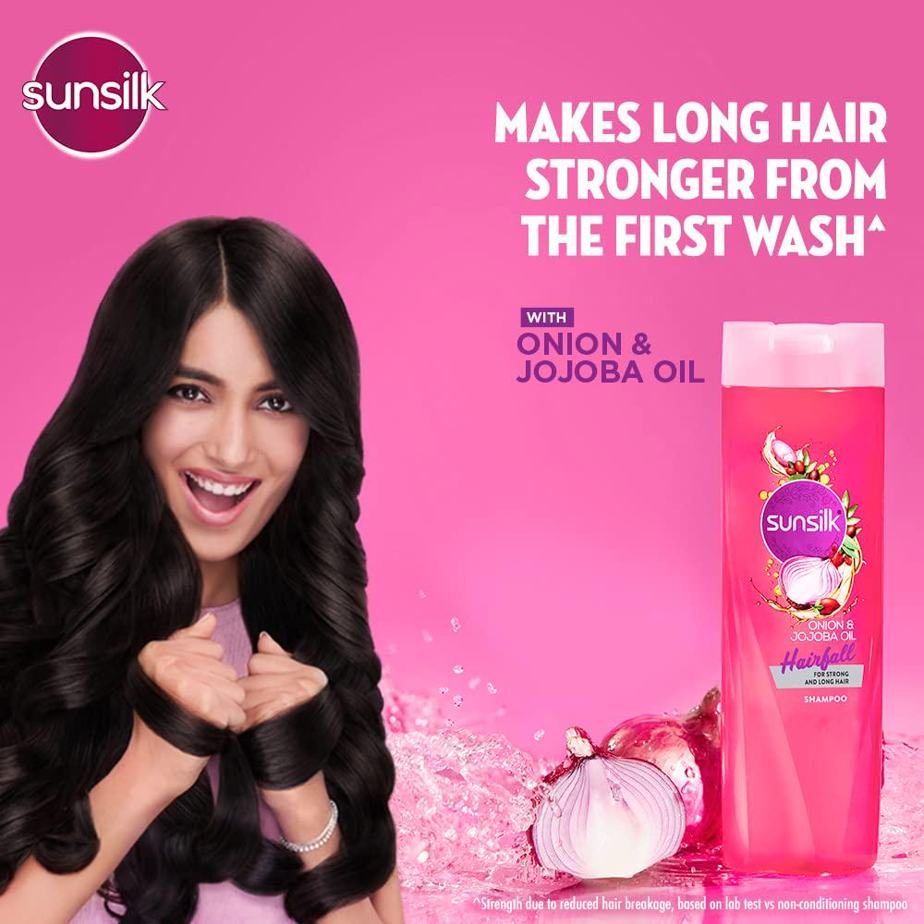sunsilk is a british hair care brand produced by the company unilever. the brand was introduced in 1954 in the uk and available in most countries globally. it is a hair care brand in southeast asia. wikipedia introduced: 1954 ambassador(s): dolla (malaysia) markets: indonesia, malaysia, singapore, thailand, vietnam, philippines owner: unilever

**5.**